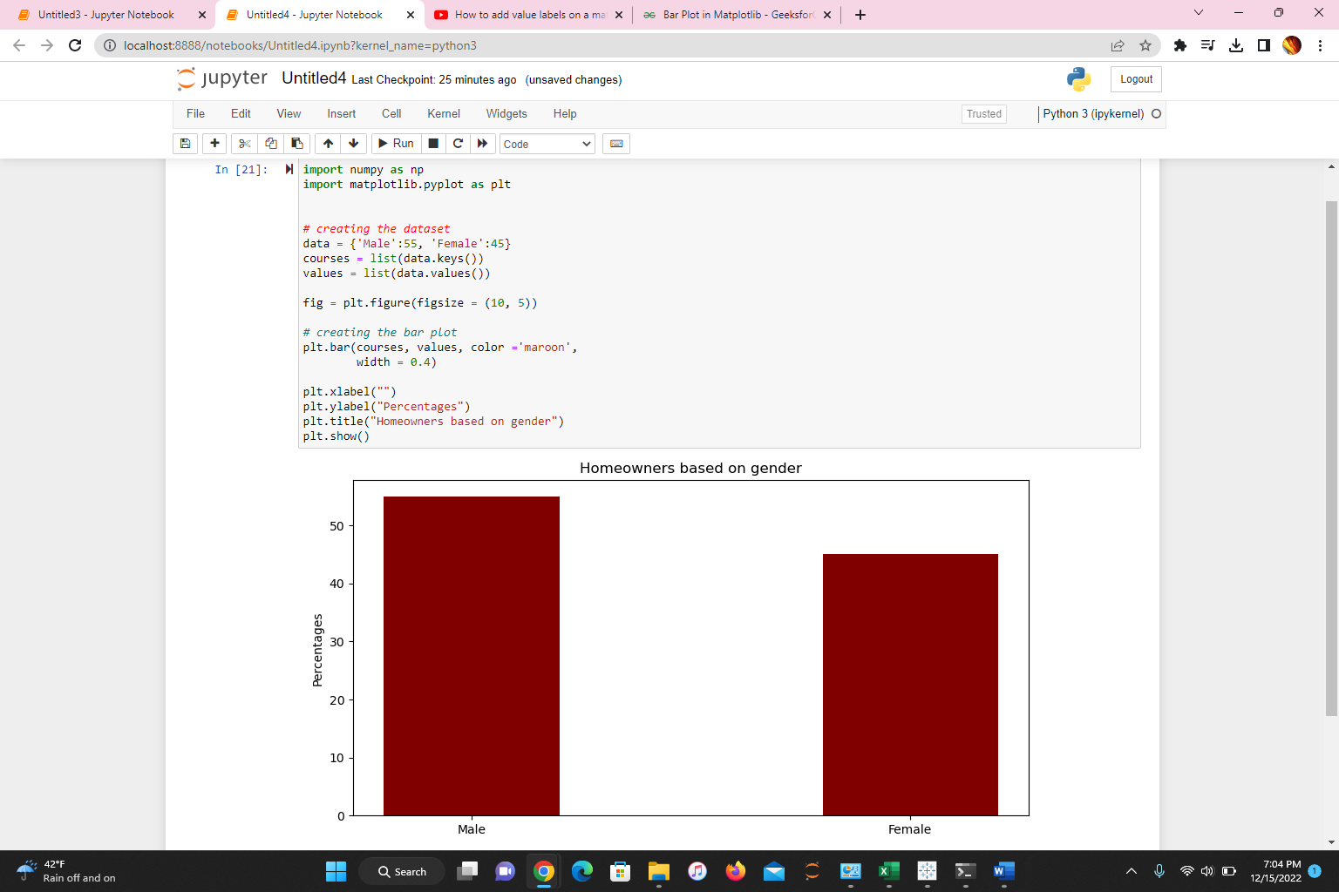

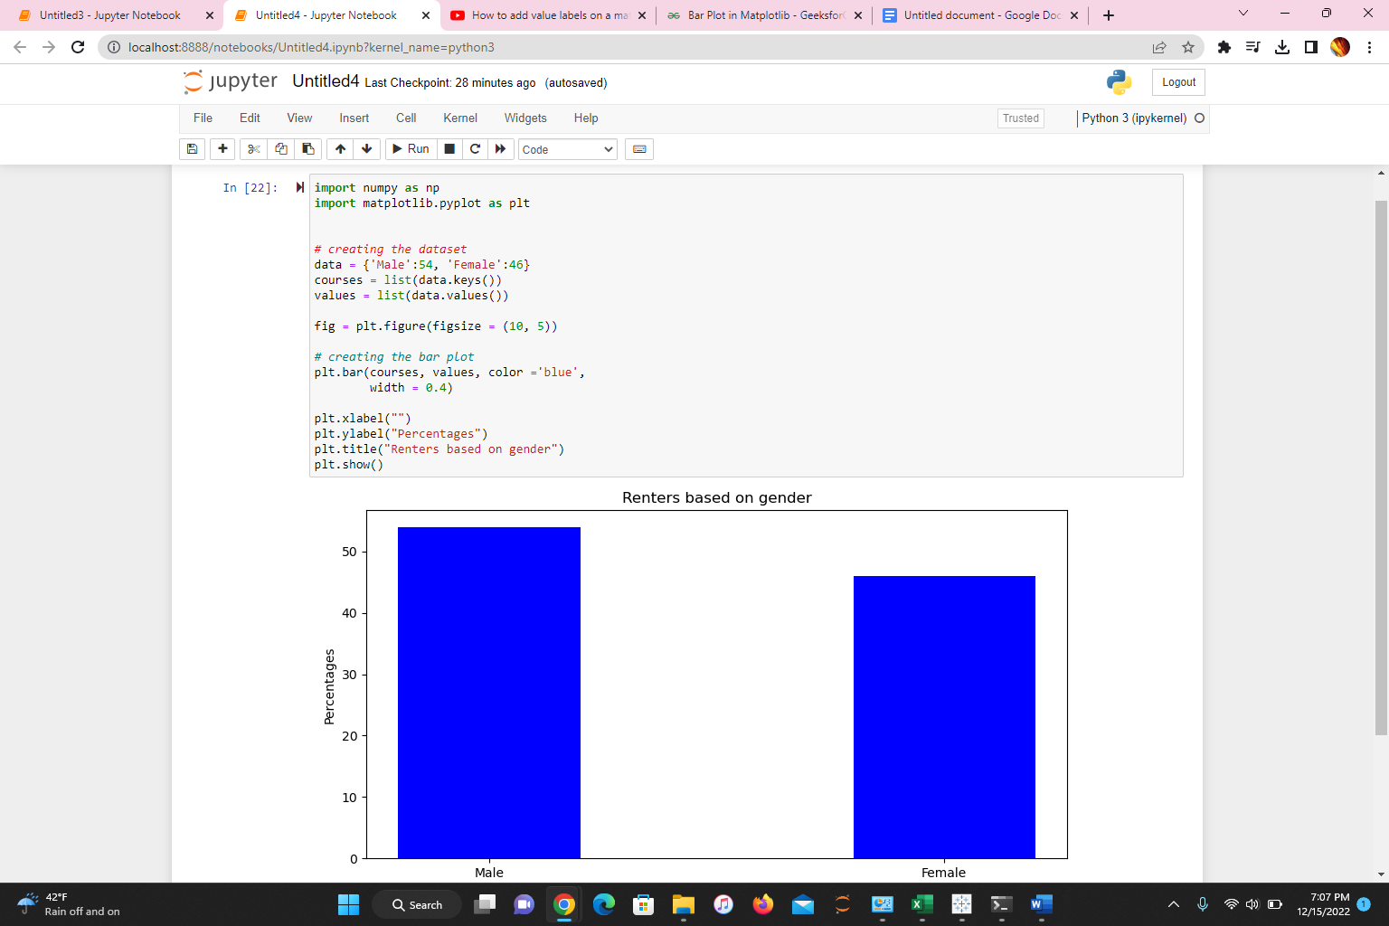

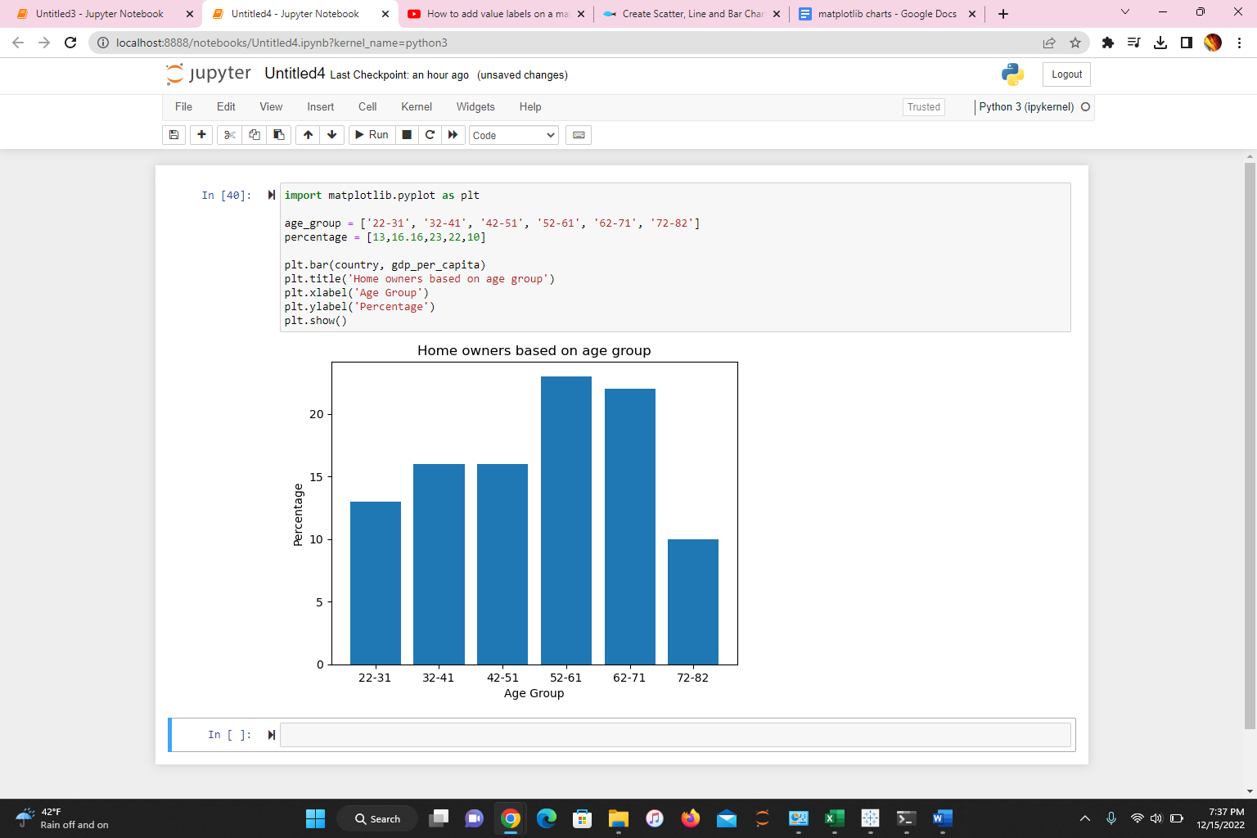

import matplotlib.pyplot as plt

age_group = ['22-31', '32-41', '42-51', '52-61', '62-71', '72-82']

percentage = [13,16.16,23,22,10]

plt.bar(age_group, percentage)

plt.title('Home owners based on age group')

plt.xlabel('Age Group')

plt.ylabel('Percentage')

plt.show()

